Unit 8: Making Use of Electricity
Topic: Constructing complete circuit
Worksheet
Name: _____________________
Class: _________________( )
Date: _______________________

Task 1 : Lighting up a bulb
You are given the following materials.
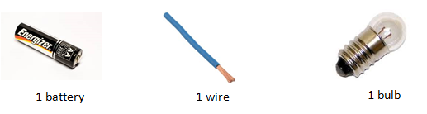
- Draw a diagram to show how a bulb can be lighted up with the materials provided.

- In order to draw the circuit diagram easily, symbols are used to represent the materials. What are the symbols for the following materials?
Electric components | Battery   | Bulb   | Wire   | Switch  
Symbols | --- --- | --- Ω --- | -------- | --- ---

- Draw a circuit diagram to show your connection in Question (1).

Task 2 : The closed circuit
Now you are given two extra wires and 1 switch. Try to make connection for the following setup. Draw the circuit diagrams and check whether the bulb will be light up or not.
Circuit | Circuit Diagram | Light up ?  √ or ×
1.  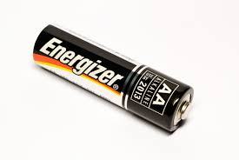  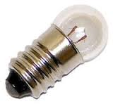 | Ω | ×
2.   | Ω | ×
3. | Ω | √
4. | Ω | ×
5. | Ω | √

The bulb can only be lighted up when there is current flow to it. What are the requirements for the current flow?
1.___closed_circuit 2. ____battery____
Task 3 : The concept of parallel and series circuit
- Identify which circuit is connected in series and which one in parallel.

Ω
Ω
Ω

Ω

__series___ circuit __parallel_ circuit

- Which of the above connections can light up the bulbs more brightly? Explain your answer.

- You are given several wires, 2 bulbs, 1 switch and 1 battery. Connect the materials in both series and parallel circuit respectively. Which of the connections can light up the bulbs more brightly?
The connection in parallel circuit can light up the bulbs more brightly.

- Compare the differences between the circuits with two bulbs in parallel and in series.
 | Circuit with two bulbs  in series | Circuit with two bulbs  in parallel
Brightness of a bulb | Less brightly | More brightly
Current delivered from the battery | smaller | Larger
Energy delivered by the battery | smaller | Larger

- Explain why there is difference between the brightness of bulbs connected in parallel and in series.
For the circuit in parallel, the energy delivered by the battery is larger and is shared by the two bulbs. Thus, the bulb of circuit in parallel is more brightly as compared with that in series.

